**Building the model for credit card approval**

* After performing data cleaning and transforming the data to numerical vectors we used keras to build our logical structure.
* Here we built a sequential model.
* Our model has 3 hidden layers along with input and output layer.
* Our input layer consisted of 27 dimensions with random weights and bias initialization.
* Here we built a fully connected network .
* Our first hidden layers consists of 28 neurons and relu as an activation function.
* Our first hidden layers consists of 18 neurons and relu as an activation function.
* Our first hidden layers consists of 8 neurons and relu as an activation function.
* In all the hidden layers we used randomly initialized weights and bias.
* In the output layer we used sigmoid as an activation function.
* To compile our model we used SGD as the optimizer with batch size of 100 and loss function as binary cross entropy and metrics as accuracy.
* We used 400 epochs to train our model.
* Here we used validation split as 0.2.

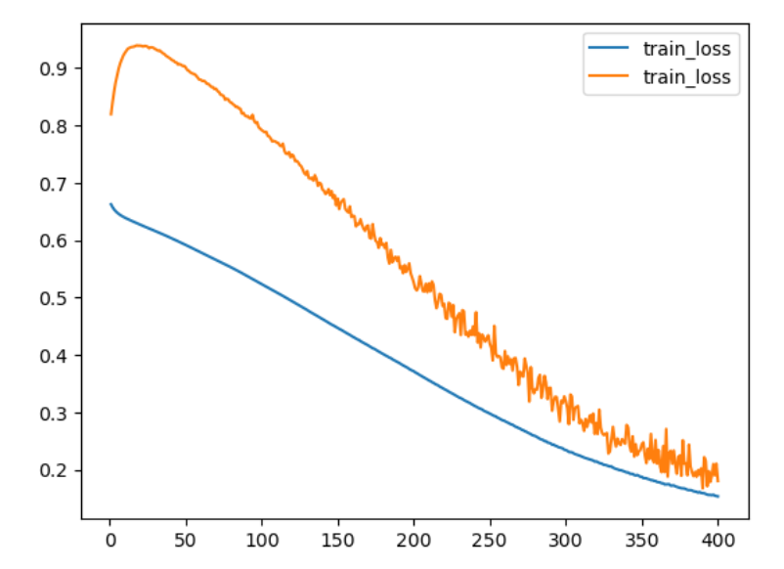

Here we can see the train and test loss

* After doing predictions on test data we used accuracy,confusion matrix and classification report to evaluate our model.
* The model is giving accuracy of 86 %.

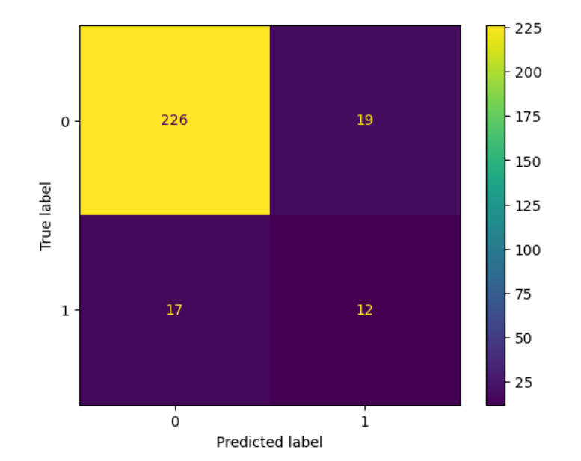

Confusion Matrix

* Here we can see that our model performed well for classifying 0 class datapoints .Out of 245 Zero class labels it is able to correctly classify 226 datapoints.
* For 1 class label out of 29 datapoints it is able to correctly classify 12 datapoints.

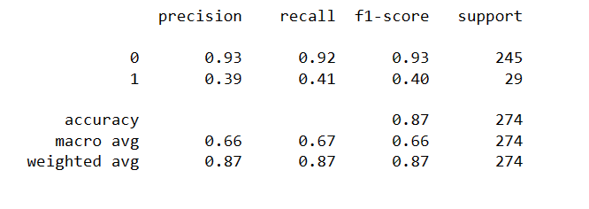

Classification report

* For the 0 class label the precision and recall both are high.
* For 1 class label the precision and recall are low.